**Learn Umrah In VR**

**(VIRTUAL REALITY BASED)**

**Ahsan Shafiq Khan**

**Jameel Ahmed**



**Department of Computer Science**

**COMSATS UNIVERSITY ISLAMABAD**

**ATTOCK CAMPUS-PAKISTAN**

SESSION 2017-2021

**Learn Umrah In VR**

**(VIRTUAL REALITY BASED)**

*Undertaken By:*

**AHSAN SHAFIQ KHAN**

CIIT/FA17-BCS-034/ATK

**JAMEEL AHMED**

CIIT/FA17-BCS-012/ATK

*Supervised By:*

**MR. SHEHZAD RIZWAN**

A DISSERTATION SUBMITTED AS A PARTIAL FULFILLMENT OF THE REQUIREMENTS FOR THE DEGREE OF BACHELOR OF SCIENCE IN SOFTWARE ENGINEERING

**Department of Computer Science**

**COMSATS UNIVERSITY ISLAMABAD**

**ATTOCK CAMPUS-PAKISTAN**

SESSION 2017-2021

**UNDERTAKEN**

We certify that this is my/our own work. The work has not, in whole or in part, been presented elsewhere for assessment. Where material has been used from other sources it has been properly acknowledged. If this statement is untrue, we acknowledge that we will have committed an assessment offence and shall be liable to punishable action under the plagiarism rules of HEC.

____________________ ____________________

AHSAN SHAFIQ KHAN JAMEEL AHMED

FA17-BCS-034 FA17-BCS-012

Dated: _________ Dated: _________

**Acknowledgment:**

We are exceedingly thankful to **ALLAH ALMIGHTY**, most gracious and merciful, who enabled us to finalize our project effectively. We have placed our entire efforts in this project. However, it would not have been possible without the faithful support of them. The help and assistance of many individuals are involved. We would like to extend our sincere thanks to everyone associated with this project in any way.

We would also like to thank **Mr. Shehzad Rizwan**. He has been there all along, so much helpful while discussing the optimization issues in this dissertation work. His critical comments on our work are of supreme importance. Those comments surely have made me think of new ideas and techniques in the fields of optimization and software simulation.

**ABSTRACT**

We have studied that the people faced so many troubles while learning about umrah from different academies. In this project, we have included a virtual reality that will help people to learn all the procedures of umrah step by step virtually and clearly than academies. People will gain more knowledge using this medium of learning.

Table of Contents

**CHAPTER 1** 8

1.1 Introduction: 9

1.2 Application Structure 9

**1.2.1 Control:** 9

**1.2.2 Achievements:** 10

**1.2.3 3D model of masjid-e-haram and safa-o-marwa hills:** 10

1.3 Application strategy: 10

1.4 Virtual Reality Interface: 10

**1.4.1 User movement:** 10

**1.4.2 Sections:** 11

1.5 Actions: 11

**1.5.1 Movement:** 12

**1.5.2 User Actions:** 12

1.6 Objectives: 12

1.7 Scope: 12

1.8 Problem Statements: 13

1.9 Proposed Solution: 13

**CHAPTER 2** 14

**Literature Review** 14

2.1 Literature Review: 15

2.2 Competitors: 15

**2.2.1 First Person Shoot:** 15

**CHAPTER 3** 16

**REQUIREMENTS SPECIFICATION** 16

3.1 Requirement Specifications: 17

**3.1.1 Functional Requirements:** 17

**3.1.2 Non-Functional Requirements:** 18

**CHAPTER 4** 20

**PROJECT DESIGN** 20

4.1 Project Design: 21

4.2 Methodology: 21

4.3 Development Tools: 21

4.4 Programming Languages: 21

4.5 System Architecture: 22

4.6 Activity Diagram: 23

**4.6.1 Activity Diagram:** 23

**4.6.2 Activity Diagram:** 24

4.7 Use Case Diagram: 25

**4.7.1 Components of use case:** 25

**4.7.2 Use Case Diagram:** 25

**4.7.3 Use Case Diagram:** 26

4.8 sequence diagram: 27

**4.8.1 sequence diagram:** 27

**4.8.2 sequence diagram:** 28

4.9 Context Diagram: 29

4.10 Conclusion: 29

# 

# **CHAPTER 1**

**INTRODUCTION**

## 1.1 Introduction:

In our daily life, Virtual reality devices are increasing day by day, Virtual reality first head-mounted display was introduced in 1960. The principal android empowered VR headsets were presented in 2014 by Google in the Google I/O meeting, Named as Google Cardboard. Most users of virtual reality devices play the game to get the perfect gameplay experience. Many Users of android phones use to play games on Mobile for the sake of entertainment and stay active. With Mobile nowadays people are moving towards Virtual reality games, to have more interaction and real-world feelings. With mobile-only games, the players don’t exercise their bodies but just sit and play, but virtual reality helps players have some physical exercise while playing the game with VR on mobile. The player can move the head in 360 degrees and get the feeling like the player is in the environment.

The Information and computer Technology (ICT) incorporate almost all aspects of life, including education and all other learning process. The current method of learning about Umrah rituals are from different academies, YouTube, text books and from different virtual apps which shows only the steps that poses difficulties for users in learning. To address such problems, this project proposes the use of virtual reality (VR) to aid in learning about all the rituals. This type of learning can help Users use both text media and 3D models, thus helping them to gain a better understanding in learning Umrah process

## 1.2 Application Structure

### **1.2.1 Control:**

The player experiences the masjid-e-haram environment that is presented in the model, through a first-person view of the scene, the person can move in the masjid haram and feel the environment.

The app is organized in different sections that corresponds to the different challenges in the Umrah performance. The user progresses in the app by each requirement of Umrah and move to the next section. Each section has its objectives.

### **1.2.2 Achievements:**

The user advances in the application by finishing each section and get the next objective of umrah performing. Each section has its tasks. A set of objectives are given in every section. After completion of objectives of corresponding section user will move to the next section having different objectives of Umrah performing. After completion of all objectives the score of the user will be assigned as the result.

### **1.2.3 3D model of masjid-e-haram and safa-o-marwa hills:**

The whole application revolves around the 3d model of Masjid-e-Haram and Safa-o-Marwa hills, our models are designed in the blender tool. It has textures and colors and different materials are used to design the model of masjid-e-haram and safa-o-marwa hills.

## 1.3 Application strategy:

This application is designed to teach the people about performing umrah, as we know that there is too much difficult for the elder people for visiting the coaching centers and taking classes about umrah performing and its faraiz. We are developing an app that will be helpful to the all of our users so they can learn at home easily.

## 1.4 Virtual Reality Interface:

The user experiences the masjid-e-haram in virtual reality. The game interface provides dominant visuals and audios like takbeerat and duas which is appealing for the user.

### **1.4.1 User movement:**

The user can freely move in the masjid Haram when he wants to visit, he can also move in safa & marwa area. This movement of the users will feel them like as they are actually moving there.

### **1.4.2 Sections:**

Sections are the main part of our application. There are four main sections and some of them are further divided into sub-sections. Different sections have their different objectives.

#### **1.4.2.1 Learning Umrah:**

The user will get options related to learning Umrah according to their gender. This section will teach the user that how to perform Umrah. It will teach all of the four main faraiz of Umrah.

#### **1.4.2.2 Performing Umrah:**

This section will allow the user to perform umrah in the 3d model of Masjid-e-Haram and Safa-o-Marwa hills. This section will calculate the user scores on the completion of all objectives and score will be displayed at the end on the basis of his/her performance.

#### **1.4.2.3 Virtual Tour:**

This section will give two options to the users ,whether they wants to take virtual tour of Masjid-e-Haram or Safa-o-Marwa hills. This section will allow the users to move freely around the models.

#### **1.4.2.4 Dua’s and Kalimat:**

This section will contain all the “Duas and Kalima’s” that are recited by pilgrims during performing Umrah.

## 1.5 Actions:

Actions are the movements that are done by the users like their movements etc.

### **1.5.1 Movement:**

Players can move anywhere in the model, enter into the Masjid-e-Haram, Safa-o-Marwa. The Player is moving left, right, forward, and backward anywhere he likes with the help of a joystick.

### **1.5.2 User Actions:**

The user will move around the “Khana-e-Kaabah” to perform **Tawaf.** User will have to make seven rounds around “Khana-e-Kaabah” to complete **Tawaf** in anti-clockwise direction. User will also make seven rounds between Safa-o-Marwa hills to perform Sahii.

## 1.6 Objectives:

* To teach all the steps of Umrah.
* To perform the Umrah in a right manner.
* To teach Kalima’s that will be recited at the time of performing Umrah in Haram Sharif.
* To remove the difficulties of old agers they face to reach tuition centers to attend the classes and learn the Umrah steps.

## 1.7 Scope:

Our project Scope includes the following:

* People will learn the method of Umrah as if they are actually doing it.
* It will be easy for the people to learn all the steps of Umrah without going to tuition center and attend the classes.
* The main purpose is less time-consumption for people to learn and this issue is resolved by this system as it performs Analytic process quickly.

## 1.8 Problem Statements:

* Although there are some applications displaying the descriptions about the sacred places of Kaaba but there is no proper application which provide learners proper 3D view using virtual reality.
* Mostly the old people face troubles while going to academies for learning Umrah process and face difficulties to get reaching in academies.
* Time consuming need a lot of time to go and attend the classes.
* Inability to keep attention during the classes.

## 1.9 Proposed Solution:

In this system we are providing a single platform which allows learners to understand complete information using virtual reality along with voice and descriptions.

# **CHAPTER 2**

# **Literature Review**

## 2.1 Literature Review:

A literature review paper is a type of academic paper, in which it includes information of fundamental findings, also include working and theoretical contribution of a relevant topic. Virtual reality is the reality trending in today's world since 2014 and still not at the mature stage. Virtual Reality provides interaction of players to the game world in an almost real way by doing physical activity you interact with virtual game play. Studying things in Virtual reality is one of the latest achievements of technology.

By determining all the needs and researching needs we came through Unity 3D a free easiest way to develop gamming applications.

## 2.2 Competitors:

The rapid penetration of advanced technology into every aspect of society, how, when, and where we operate, how individuals and companies manage themselves, and the game to complement other development companies. How our game should be structured is undergoing significant change. Continuing and developing similar games will not do us any good in completing them.

### **2.2.1 First Person Shoot:**

The FPS is a popular VR based game in which the environment is provided in such a way that the player will need to divert his full attention towards the environment. The user will be able to experience the most extreme environments by interacting with some steps which are usually performed in Umrah.

# **CHAPTER 3**

# **REQUIREMENTS SPECIFICATION**

## 

## 3.1 Requirement Specifications:

In this chapter, we have all the functional and Non-Functional requirements of our application.

### **3.1.1 Functional Requirements:**

The Functional Requirement of any system can be related to both hardware and software in terms of specific functionality which can define what can a specific system able to accomplish. A functional requirement is in the form of a professional document which explains the desired output when the system is deployed in certain kinds of environment.

#### 3.1.1.1 Display:

|  |  |
| --- | --- |
| **FR-NO** | FR-01-01 |
| **FR-Name** | Display |
| **Summary** | This app must be open in laptops and the User has the options to play in full-screen size. |

**Table 3.1 Display**

#### **3.1.1.2 Development Tools:**

|  |  |
| --- | --- |
| **FR-NO** | FR-01-02 |
| **FR-Name** | Development Tools |
| **Summary** | This is implemented in C# scripts and developed in Unity 3D engine |

**Table 3.2 Development Tools**

#### 3.1.1.3 The Controls:

|  |  |
| --- | --- |
| **FR-NO** | FR-01-03 |
| **FR-Name** | Control |
| **Summary** | It must be control with VR oculus and Joy Stick. |

**Table 3.3 The Controls**

#### 3.1.1.4 Operating System Control:

|  |  |
| --- | --- |
| **FR-NO** | FR-01-04 |
| **FR-Name** | Android |
| **Summary** | It must be played on Android OS and compatible with VR devices. |

**Table 3.4 Operating system Controls**

### **3.1.2 Non-Functional Requirements:**

The Non-Functional requirements describe the characteristics of the system it describes how a system performs and behaves based on limits of functionality. Also defines the limits on different functionalities are. For example, response time, system validation, etc.

#### 3.1.2.1 User Interface:

|  |  |
| --- | --- |
| **NFR-NO** | NFR-01-01 |
| **NFR-Name** | User Interface |
| **Summary** | User interface Should be clean and compatible with mobile screens and UI must be controlled through Gear VR. |

**Table 3.5 User Interface**

#### 3.1.2.2 Quality Graphics:

|  |  |
| --- | --- |
| **NFR-NO** | NFR-01-02 |
| **NFR-Name** | Safety Quality Graphics |
| **Summary** | It must have high-end 3D Graphics. |

**Table 3.6 Quality Graphics**

#### 3.1.2.3 Performance:

|  |  |
| --- | --- |
| **NFR-NO** | NFR-01-03 |
| **NFR-Name** | **Performance** |
| **Summary** | The primary performance requirements are the speed of the play. It must be with good FPS on system to have more reality |

**Table 3.7 User Interface**

# 

# **CHAPTER 4**

# **PROJECT DESIGN**

## 4.1 Project Design:

The project design chapter consists of the Methodology used to develop our game, Tools, Programming language, and Game Architecture.

## 4.2 Methodology:

In this system we'll use incremental method which allows us to modify or add-up modules or functionalities as per demand/requirement.

Incremental phases:

* 1. Requirement gathering
  2. Design
  3. Implementation

## 4.3 Development Tools:

* Unity 3D.
* Blender.
* Visual Studio

## 4.4 Programming Languages:

* C# Scripting

## 4.5 System Architecture:

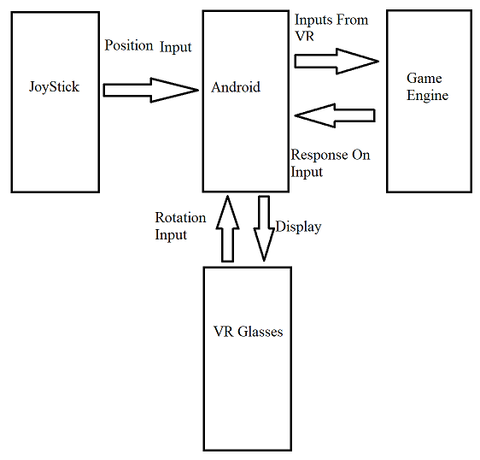

## 4.6 Activity Diagram:

In this array we are showing a graphical representation of the workflow of phased activities. This diagram shows the overall flow control. Activity diagrams can be formed with a small number. Here are the key shapes

1. Arrows show the order of activities in which they are happening.
2. Start represented with black circle.
3. Action represented with rounded rectangle.
4. End is represented with encircled black circle.

### **4.6.1 Activity Diagram:**

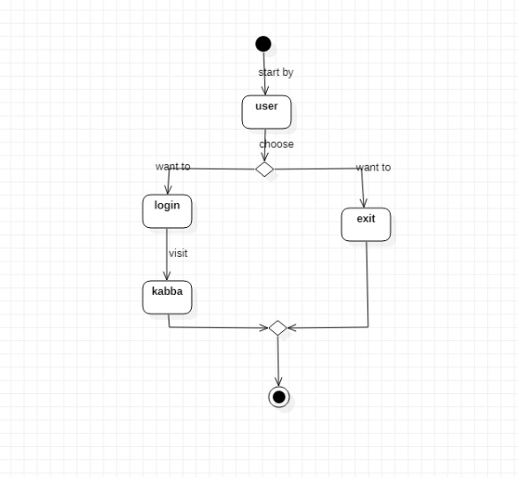

When user login he will get the option of Kaaba if he wants to perform umrah he will click the Kaaba option then further all the steps will be shown.

### **4.6.2 Activity Diagram:**

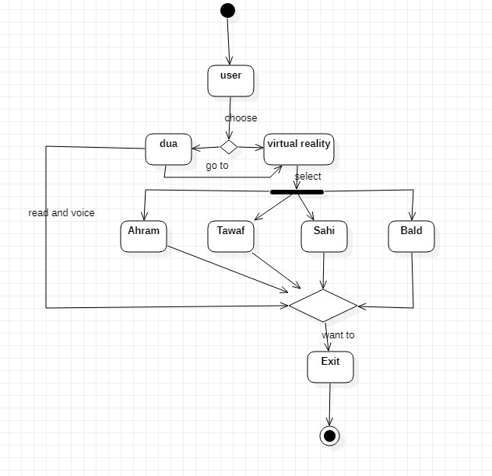

When the user selects the Kaaba option then he will start to perform all the steps of umrah further there are 4 steps of umrah which the user will be perform and that’s are wear ihram doing tawaf around the Kaaba after this user will do sahi and the last step is balding.

## 4.7 Use Case Diagram:

The use case diagram is used to briefly discuss the need for the system. This includes actions taken by actors, systems, users and specific actors. This method is used for system analysis and helps identify, define and organize system requirements. There is only one actor in our application and that is user.

### **4.7.1 Components of use case:**

**1.** Use case defines the relationship amongst and between the actors.

**2**. The threshold is used to identify system actors, system users.

### **4.7.2 Use Case Diagram:**

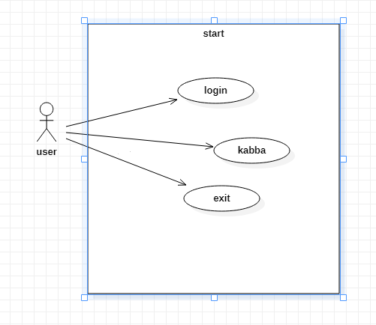

User will login and he/she will get two options (Kaaba) and (Exit) either user want to visit the VR Kaaba then user will select the Kaaba option if user want to go back and didn’t want to visit the Kaaba, he will click the exit option.

### **4.7.3 Use Case Diagram:**

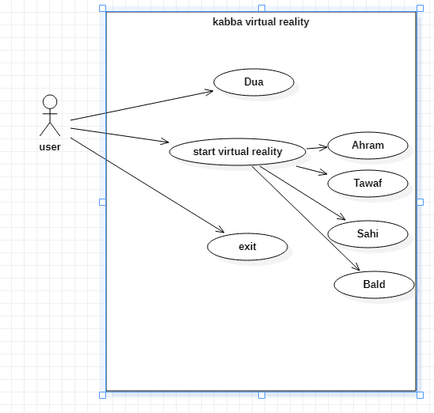

After login the user will be display 3 options which is shown in above diagram when the user wants to perform umrah he will select the option start VR further there are 4 steps of umrah.

## 4.8 sequence diagram:

A sequence diagram is defined in the software system configuration. It is represented by parallel lines that represent events and horizontal lines at the beginning and end that represent the system and the user.

### **4.8.1 sequence diagram:**

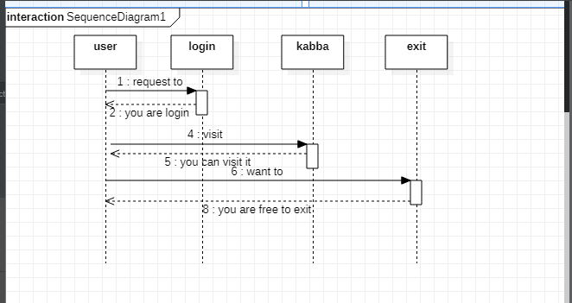

Initially Users will register/login themselves. If the user details are valid according to database, then his account will be opened. Users see their information which we put in our app. When the user login then he will select Kaaba options when he wants to go back, he will select the exits option.

### **4.8.2 sequence diagram:**

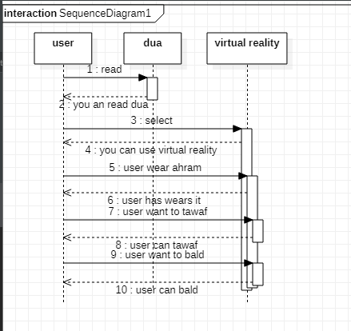

When user want to perform umrah first he will wear the Ihram after this he will start the tawaf around the Kaaba after completing the 7-circle user will move to perform sahi after finishing sahi then user will bald then the umrah will be completed.

## 4.9 Context Diagram:

User

Unity Engine

Play Load menu

Select option Option load

Perform Score

Completed

The user starts the playing by clicking the icon and the unity engine load the main menu to the user. User select stage, Unity Engine load the stage. The VR umrah will display shows the challenge to the user required to complete the all steps of umrah. The user starts to perform and complete the challenge. The unity engine displays Achievement on the screen and shows to performing umrah.

## 4.10 Conclusion:

In this chapter we discuss all project designs including activity diagram, context diagram, use case diagram and continuity diagram. All these diagrams illustrate the design of our project which we discuss in this chapter. The activity diagram shows a step-by-step description of the activities. The sequence diagram describes the system sequentially. Using the case diagram shows the requirements of the system. The context diagram shows the initial level of the system.